Children’s CellNewsletter

*August 6, 2023*

**Dear Parents,**

Thank you so much for allowing your child to join our service.   
I’d love for you to use this newsletter to review this week’s Bible story with your child at home.

Today, we’ll learn about **“People Welcomed Jesus as King”** (Matthew 21; Mark 11; Luke 19; John 12). *A king is a person of importance because he rules over others and governs a kingdom. We would want to welcome a king by showing him honor and respect. In our story today, the people in Jerusalem welcomed a King—King Jesus.*

Review the gospel and encourage your child(ren) to speak with you if they have questions. Remind your child(ren) that in today’s story, the people of Jerusalem showed praise to Jesus by laying down cloaks and palm branches. We can use the gifts God has given us to praise Him as the rightful King as well. Explain that Jesus is worthy of all praise because He alone is the King of kings. Then **pray, hanking God for keeping His promise to send the Messiah to save us from sin.**

*Grace and blessings in Christ,*

**Danny Sungshin Park** *Pastor of Children’s Cell* SParkforChrist@gmail.com



**People Welcomed Jesus as King**

|  |  |
| --- | --- |
| BIBLE PASSAGE: | **Matthew 21; Mark 11; Luke 19; John 12** |
| KEY PASSAGE: | **Deuteronomy 18:15** |
| BIG PICTURE QUESTION: ***How is Jesus the perfect Prophet?***  **Jesus perfectly reveals God the Father and fulfills what the prophets spoke.** | |

Jesus and His disciples traveled toward Jerusalem. When they neared Bethphage (BETH fayj) and Bethany near the Mount of Olives, Jesus sent two of His disciples ahead into a village. “As soon as you enter the village,” Jesus told them, “you will find a young donkey tied there. No one has ever sat on it. Untie it and bring it here. If anyone says to you ‘Why are you doing this?’ say, ‘The Lord needs it.’”

The disciples did as Jesus commanded. When they untied the donkey, its owners asked what they were doing. “The Lord needs it,” they said. Then they brought the donkey to Jesus, threw their robes onto the donkey, and helped Jesus get onto it. Jesus rode the donkey down the road. Along the way, people spread their robes on the road for Jesus, and others spread palm branches cut from the fields.

People walked behind and ahead of Jesus, praising God with a loud voice for all the miracles they had seen. “Hosanna!” they said. “Blessed is He who comes in the name of the Lord! Hosanna in the highest heaven!” The word hosanna means “save now.” The people welcomed Jesus as their promised King. They hoped He would save them from the Romans.

Some religious leaders told Jesus to make His disciples be quiet. Jesus answered, “If they were to keep silent, the stones would cry out and praise Me!”

Jesus entered Jerusalem and went to the temple. People who were blind and people who were disabled came to Him. Jesus healed them. Other religious leaders saw Jesus’ miracles and heard the children saying, “Hosanna to the Son of David!” They were very angry and asked Jesus, “Do You hear what these children are saying?”

“Yes,” Jesus told them. The writer of Psalms had said, “You have prepared praise from the mouths of children and nursing infants.”

*Jesus is the Messiah spoken about by the prophet Zechariah: “Look, your King is coming to you; He is righteous and victorious, humble and riding on a donkey, on a colt, the foal of a donkey” (Zechariah 9:9). One day, Jesus will return to earth on a white horse as King over everything.*

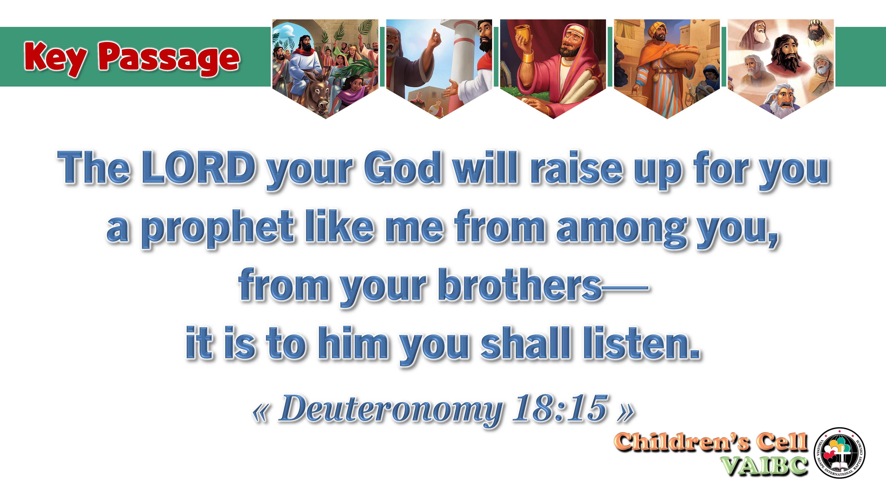

***〔 Important Notice 〕**

* Children’s cell worship service will start at 12:00 noon.
* Remind your children **not to play with electronic devices or toys** such as smartphones or dolls, during our service.
* Our prayer is that the children’s time spent in our church would encourage them to trust Christ as Savior, to submit to Him, and to live out the Gospel wherever they are.

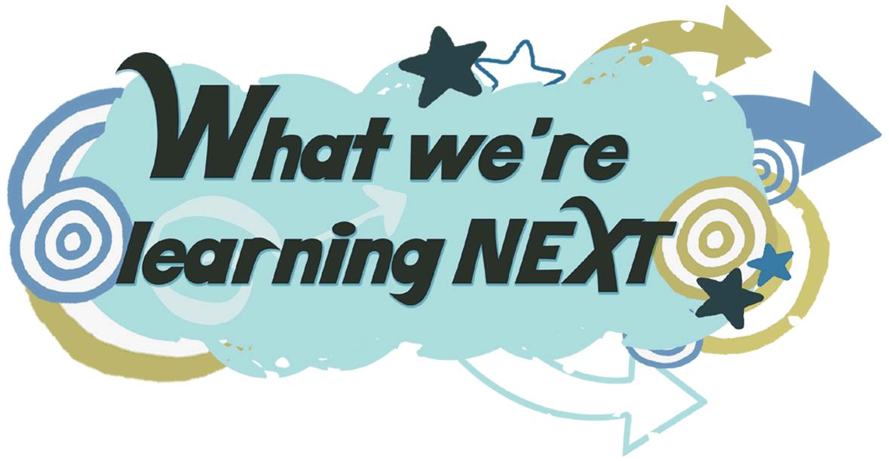

**“Leaders Wanted to Trick Jesus”** (Matthew 22)

